[1026. Maximum Difference Between Node and Ancestor](https://leetcode.com/problems/maximum-difference-between-node-and-ancestor/description/)

Given the root of a binary tree, find the maximum value v for which there exist **different** nodes a and b where v = |a.val - b.val| and a is an ancestor of b.

A node a is an ancestor of b if either: any child of a is equal to b or any child of a is an ancestor of b.

**Example 1:**

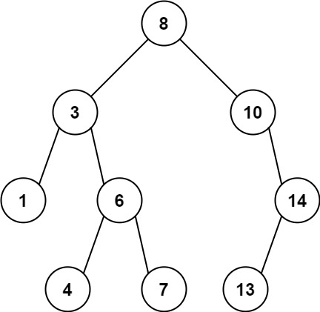

**Input:** root = [8,3,10,1,6,null,14,null,null,4,7,13]

**Output:** 7

**Explanation:** We have various ancestor-node differences, some of which are given below :

|8 - 3| = 5

|3 - 7| = 4

|8 - 1| = 7

|10 - 13| = 3

Among all possible differences, the maximum value of 7 is obtained by |8 - 1| = 7.

**Example 2:**

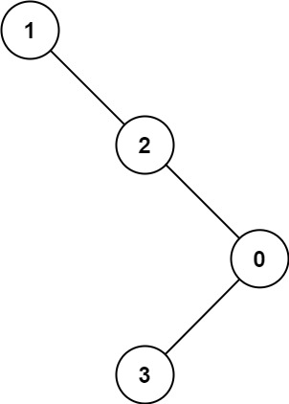

**Input:** root = [1,null,2,null,0,3]

**Output:** 3

**Constraints:**

* The number of nodes in the tree is in the range [2, 5000].
* 0 <= Node.val <= 105